**MEETING MINUTES: SUMO DIGITAL GROUP PROJECT**

**Date of meeting:** 27/02/2019

**Time of meetin**g: 10:10 AM

**Attendees**: Dragos Liche, Dawid Hojka, Alex Butler and Anthony Skipwith

**Post-mortem of previous week:**

**What went well:** Most tasks were completed on time, and JIRA was updated accordingly. All tasks were also uploaded into GitHub as soon as possible. Most of the work was completed over the duration of the session, and the remainders were completed over the duration of the week. All the work was completed to the high quality as expected, with small mistakes.

**What went badly**: Anthony’s task regarding implementation of features was still in-progress at the end of the sprint, so he will need to continue working on it this sprint. Alex’s models had some texturing issues, so he will take a short time at the beginning to fix them.

**Feedback received**: We have received some gameplay-related feedback from Rob during our meeting with him. He suggested that we should consider things like a potential play-time of our game, whether certain assets are necessary at this point in-time, like the outer area of the level, or the extended amount of character designs. He also talked about how we should consider the players, in terms of what they would be looking for when playing the game, and how we could use that knowledge to design and balance the game.

**Individual work completed:-**

* **Dragos:** Completed the trumpet and umbrella 3D weapon assets.
* **Dawid:** Animated the 3 characters walking, along with 1 colour variant for each character.
* **Anthony:** Researched enemy pathfinding and started adding all the features into a singular project.
* **Alex:** Completed the large table and table chair 3D assets.

**Overall aim of the current week’s sprint**

The overall aim of this week is to make sure that we have the minimum viable product ready for the pitch next week. That mainly includes the main features of the game, so reticle movment aim system and enemy spawning and movement in a bar setting.

**Tasks for the current week:-**

* **Dragos:** His main task for the week is to create 3D props for the level that we can later import into the level, to make sure the bar setting is recognizable.
* **Dawid:** His tasks for the week include creating the spritesheets for the animated characters and researching how they work in Unity, most importantly how the opacity works, so that the characters don’t have white/black background behind them when in-game. Along with that, he will also create 3D props for the level.
* **Anthony:** His task for the week is to make sure that all features in the game work. So pseudo-random reticle aiming, enemy movement, UI, as well as player movement and combat. Once that is done, he will focus on adding all the assets into the game and make sure they work correctly.
* **Alex:** His main task for the week is to research and design pieces of UI, mainly the reticle. Along with some texture clean-up for his models he did last week.

**Meeting ended:** 10:30 AM

**Minute taker:** Dawid Hojka

**Discord Discussion Documentation:**

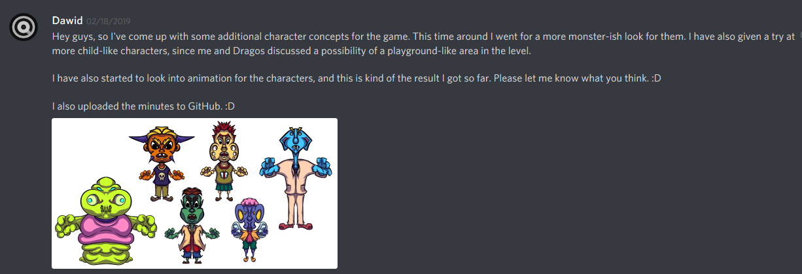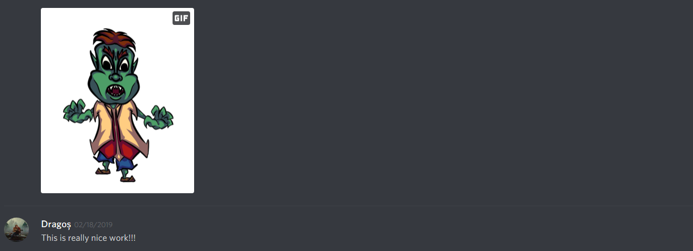

Screenshots - 2 - Dawid has updated us about his task, showing some more potential character designs.

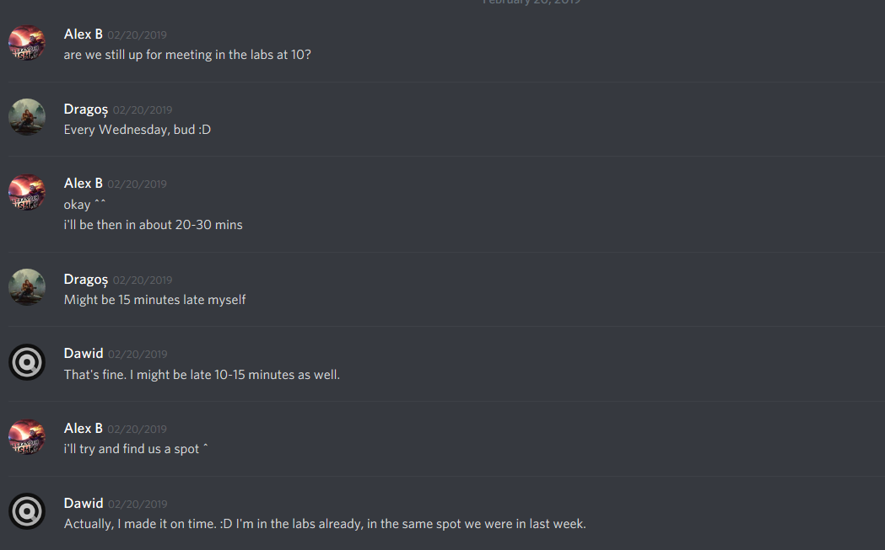

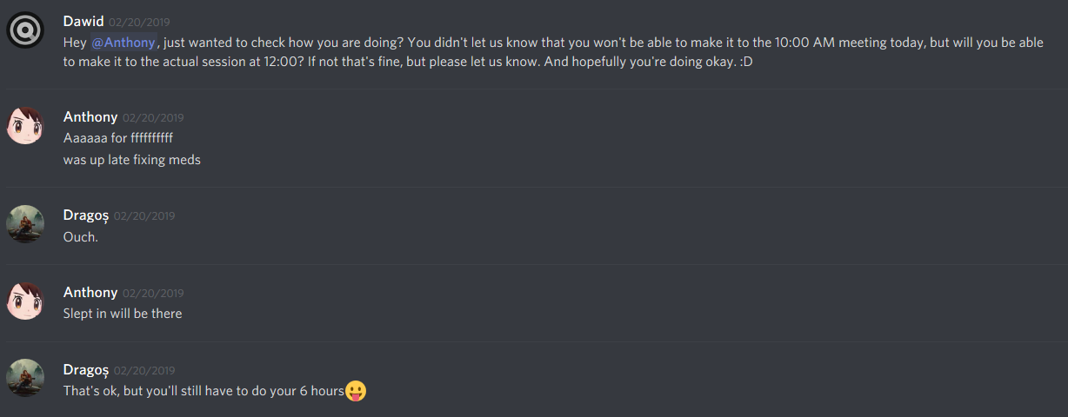

Screenshots 3 - 4 - Discussing whether we will all meet at 10 and that some of the members may be late.

 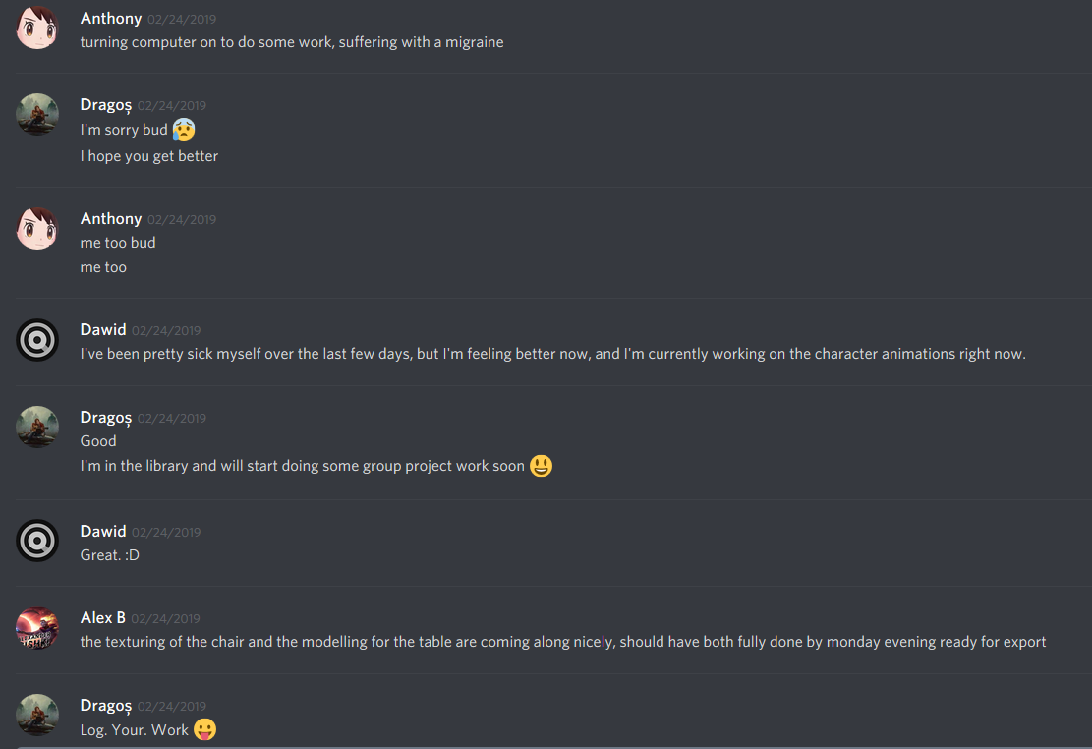 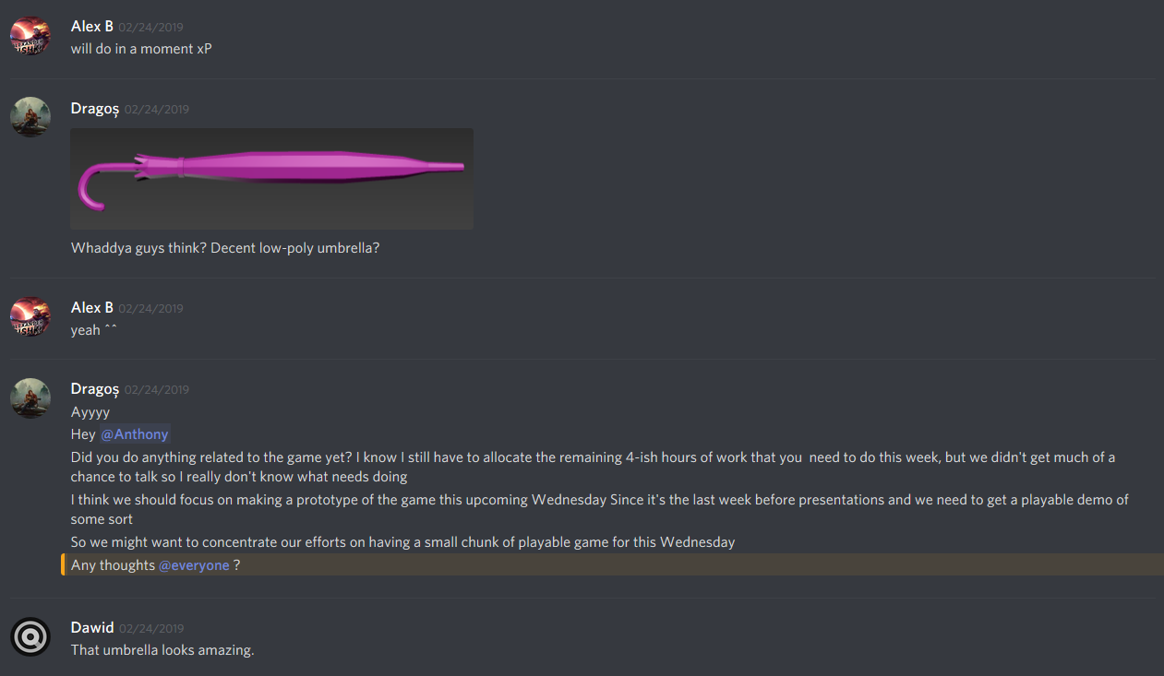 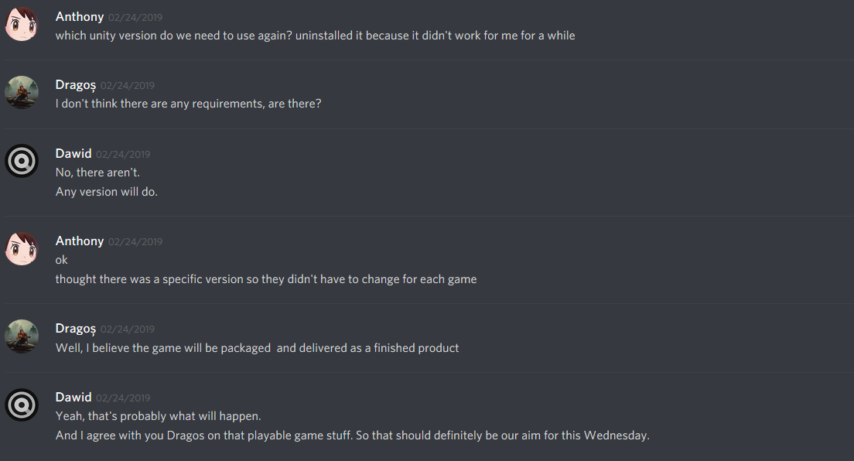

Screenshots 5 - 8 – Dragos asking us about how are we progressing with our tasks and a discussion revolving around the tasks and what our aim should be for the upcoming sprint. 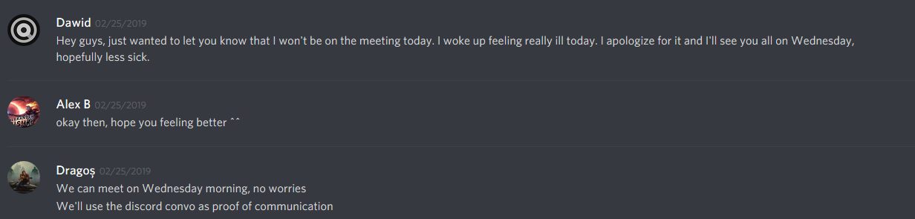 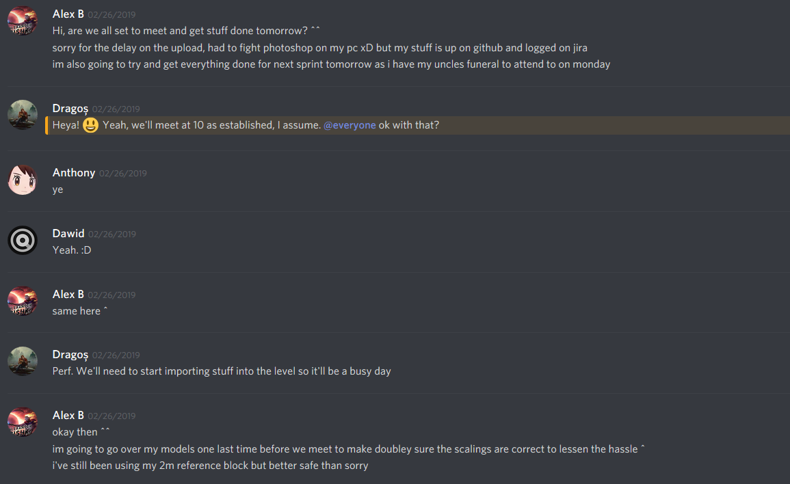 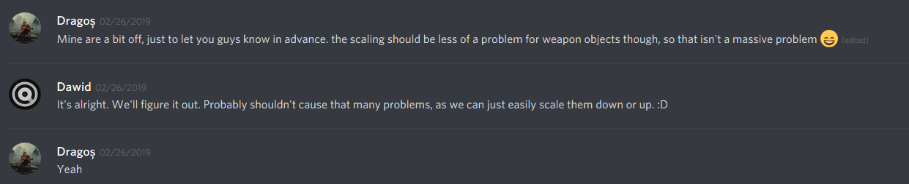

Screenshots 9 - 11 – Dawid letting us know that he won’t be able to make it to the Monday meeting, and the Monday meeting being pushed to Wednesday instead. And further is the discussion determining at what time we will meet on Wednesday.